THE GUIDE TO FORMAT YOUR ABSTRACT FOR BOOK OF ABSTRACTS OF
9-th International Scientific School for Young Scientists
“WAVES AND VORTICES IN COMPLEX MEDIA”
(FOR ABSTRACTS IN MS Word FORMAT)

J.J. AuthorName ¹, J.J. AuthorName ¹, J.J. AuthorName ²

¹ Full Institution name of the 1st and 2nd authors, City, Province, Country, e-mail

² Full Institution name of the 3rd author, City, Province, Country, e-mail

As the authors are expected to prepare camera ready file. The authors are responsible for the contents and formatting of abstract.
THE CONTACT ADDRESSES OF EDITORIAL BOARD.
The e-version of abstract and registration form should be sent to the Organizing committee of Seven International Scientific School for Young Scientists “WAVES AND VORTICES IN COMPLEX MEDIA” by one of the following e-mail addresses
yulidch@gmail.com, chakin@ipmnet.ru, chaplina_to@inbox.ru
THE DEADLINES TO SEND THE ABSTRACT TEXT.
The speaker’s text of abstract formatted by the following template should be the latest received by Organizing committee on October 01, 2016.

PAGE SIZE, FONTS AND TITLE.
The paper size is A4, all the margins on the page should be 2.5 cm. The line-to-line spacing should be single.
The title of abstract should be keyed in capital letters, font “Times New Roman”, Bold, font size 12 pt, align – center.
The next paragraph (align – center): the author(s) name(s) (“Times New Roman”, Italic, font size 12 pt); appellation of organization, city, country, e-mail address (“Times New Roman”, Italic, font size 12 pt).
The title of new section of abstract should be keyed in CAPITAL letters (“Times New Roman”, Bold, font size 12 pt, the paragraph indent − 1 cm. The text follows by title in the next line. The line-to-line spacing should be single.
MAIN TEXT.
The text of abstract is “Times New Roman” Regular, font size 12 pt, justified. The paragraph indent − 1 cm, the line-to-line spacing – single. The references should be placed in the square brackets [1, 2-3] in the order of their appearance in the text, the complete list of references is added at the end of the text.
FIGURES.
All figures in the abstract are numbered. The figure can be disposed in any suitable place in the text area. The explanations to the figures should be placed into the caption.
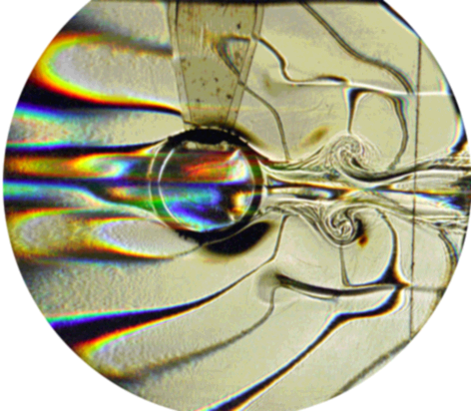
Fig. 1. The text after figures should be typed by Italic font and formatted at center. Sufficient explanation of every figure should be given. Text interval for figure captions is single.

Please do not include any additional objects into the figures. Single-image figures are recommended allowing rescaling and moving across the text without distortion. Incorporating figures into borderless tables (as in Fig.1) is allowed. The references to the figures in the text have are: fig. N. The figures and the captions should be aligned at the center of the page.

ACKNOWLEDGMENTS
Here you can acknowledge your grants and thank your colleagues. (Font Times New Roman, 10pt)

REFERENCES
The list of references should be formatted as “list”. Each reference should include: surname and the initials of the authors (Italic font), title of the book or article, title of the journal, an edition place, year, volume and number, the range of pages (for articles). For example:

- Kistovich A.V., Chashechkin Yu.D. Regular and singular components of periodic flows in the fluid interior // J. Appl. Math. Mech. 2007. V. 71. P. 762 – 771.
- Lugt H.J. Introduction to vortex theory. – Potomac Maryland: Vortex Flow Press. 1996.
- Stepanova E.V. Study of the rotating fluid surface form in the cylindrical container // Selected papers of international conference “Fluxes and structures in fluids”. Moscow. 2006. P. 313 – 319.

