THE GUIDE TO FORMAT YOUR ABSTRACT FOR BOOK OF ABSTRACTS OF CONFERENCE “FLUXES AND STRUCTURES IN FLUIDS”
(FOR ABSTRACTS IN MS Word FORMAT)

J.J. AuthorName ¹, J.J. AuthorName ¹, J.J. AuthorName ²

¹ Full Institution name of the 1st and 2nd authors, City, Province, Country, e-mail

² Full Institution name of the 3rd author, City, Province, Country, e-mail

INTRODUCTION
Instruction contains detailed rules to format text of abstract to «FLUXES AND STRUCTURES IN FLUIDS».
Authors are expected to prepare camera ready file. They are responsible for the contents and formatting of abstracts. The abstract frame is 16 x 24 cm. It is strongly recommended to insert your text in this file by copying and pasting.

PAGE SIZE, FONTS AND TITLE.
The paper size is A4, all the margins on the page should be 2.5 cm. The line-to-line spacing should be single.
The title of abstract should be keyed in capital letters, font “Times New Roman”, Bold, font size 12 pt, centered.
The next paragraph (aligned to center) contains the author(s) name(s) (“Times New Roman”, Italic, font size 12 pt); appellation of organization, city, country, e-mail address (“Times New Roman”, Italic, font size 12 pt).
The title of new section of abstract should be keyed in CAPITAL letters (“Times New Roman”, Bold, font size 12 pt, the paragraph indent − 1 cm. The text follows the title in the next line. The line-to-line spacing should be single.

MAIN TEXT.
The text of abstract is “Times New Roman” Regular, font size 12 pt, justified. The paragraph indent is 1 cm, with the single line-to-line spacing. The references should be placed in the square brackets (i.e. [1, 2-3]) in the order of their appearance in the text, the complete list of references is added at the end of the text.

FIGURES.
All figures in the abstract are numbered. The figure can be disposed in any suitable place within the text. The explanations to the figures should be placed into the caption.

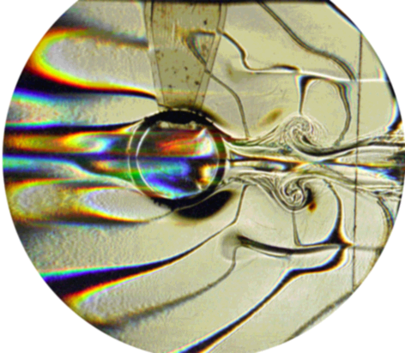
Fig. 1. The text after figures should be typed by Italic font and formatted at center. Sufficient explanation of every figure should be given. Text interval for figure captions is single.
Please do not include any additional objects into the figures. Single-image figures are recommended allowing rescaling and moving across the text without distortion. Incorporating figures into borderless tables (as in Fig.1) is allowed. The references to the figures in the text should be like this: fig. N. The figures and the captions should be aligned at the center of the page.

ACKNOWLEDGMENTS
Here you can acknowledge your grants and thank your colleagues. (Font Times New Roman, 10pt)

REFERENCES
The list of references should be formatted as a numbered list. Each reference should include: surname and the initials of the authors (Italic font), title of the book or article, title of the journal, an edition place, year, volume and number, the range of pages (for articles). See examples below.

- Kistovich A.V., Chashechkin Yu.D. Regular and singular components of periodic flows in the fluid interior // J. Appl. Math. Mech. 2007. V. 71. P. 762 – 771.
- Lugt H.J. Introduction to vortex theory. – Potomac Maryland: Vortex Flow Press. 1996.
- Stepanova E.V. Study of the rotating fluid surface form in the cylindrical container // Selected papers of international conference “Fluxes and structures in fluids”. Moscow. 2006. P. 313 – 319.

