THE CONTACT ADDRESSES OF ORGANIZING СOMMITTEE
The e-version of an abstract and a registration form should be sent to the Organizing Сommittee
of the 3nd International Scientific School for Young Scientists
"Physical and mathematical modeling of processes in geomedia"
to one of the following e-mail addresses:
sea@phys.msu.ru, chaplina_to@inbox.ru, wikarev@ipmnet.ru

THE GUIDE TO FORMAT YOUR ABSTRACT FOR BOOK OF ABSTRACTS
"PHYSICAL AND MATHEMATICAL MODELING
OF PROCESSES IN GEOMEDIA"

J.J. AuthorName ¹, J.J. AuthorName ¹, J.J. AuthorName ²
¹ Full Institution name of the 1st and 2nd authors, City, Province, Country, e-mail
² Full Institution name of the 3rd author, City, Province, Country, e-mail

An abstract should have volume 2-3 pages (font Times New Roman, 12 pt). The page fields on all sides are 2 cm. The paragraph indent is 1 cm, the text interval is single. The references should be placed in the square brackets [1, 2 - 3] in the order of their appearance in the text, the complete list of the references is added at the end of the text. All figures in the abstract are numbered. The figure can be disposed in any suitable place in the text area. The explanations to the figures should be placed into the caption.

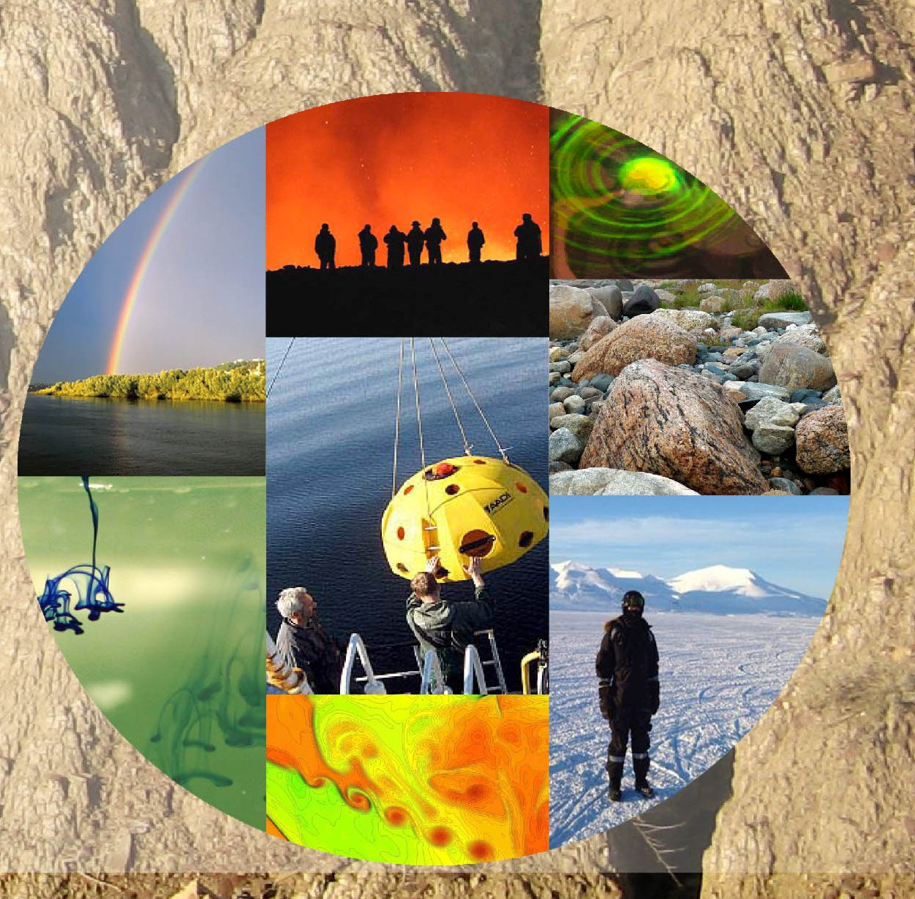
Fig. 1. The text after figure should be formatted at the center. Sufficient explanation of every figure should be given. Text interval for figure captions is single.

The references to the figures in the text have are: Fig. N. The figures and the captions should be aligned at the center of the page.

ACKNOWLEDGMENTS

Here you can acknowledge your grants and thank your colleagues. (Font Times New Roman, 10 pt)

REFERENCES

- Klimov, D.M., Karev, V.I., Kovalenko, Yu. F. & Ustinov, K. B., 2013. Mechanical-mathematical and experimental modeling of well stability in anisotropic media. Mech. of Sol. 48: 357-363.

